Chemical Plant Turnaround
Industry: Chemical Manufacturing
Focus: Capacity Recovery and System Synchronization

● At a Glance
- Environmental regulations forced shutdown of one of two parallel lines, creating a critical bottleneck.
- Management believed utilization was at 85%; LTA revealed effective OEE closer to 60%.
- Target output was 400 tons/day; engineering proposed $12M to boost capacity by ~50–60%.
- Final outcome: single line reached 750 tons/day using partial assets from the shut unit.
- Total investment: ~$150K—nearly double the capacity at 1% of projected cost.

🏭 The Situation
A traditional chemical manufacturing plant faced operational turbulence on multiple fronts. A recent labor dispute had reduced staffing and shaken morale. An environmental lawsuit forced the shutdown of one of two parallel production lines, triggering strict internal supervision. Competitive pressure was growing as rivals scaled up production. Inside the plant, speculative and high-cost engineering proposals to break the bottleneck reflected a deep uncertainty about how to move forward. But a quieter path began to take shape—starting with observation, analysis, and engagement at the operator level.

❌ The Challenge
The core obstacle was a deeply embedded culture of over-engineering and deference to legacy assumptions. Safety concerns—justified given the use of corrosive, flammable, and potentially explosive materials—had over time hardened into rigid operational dogmas. Internal and external engineering voices dominated the decision-making process, often relying on averaged observations elevated to the level of unquestioned truth. Risk aversion and consensus-seeking further cemented these taboos. As a result, critical parts of the chemical reaction process were intentionally underutilized, despite existing evidence of safe margins for increased throughput. Meanwhile, other parts of the plant ran below nominal capacity due to instability or chronic neglect—creating hidden constraints that were misattributed or ignored.

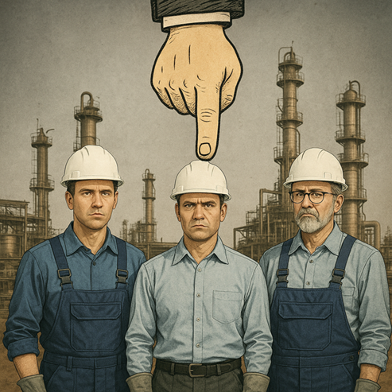

🔬 The Underlying Theory
The prevailing belief in the plant was that utilization hovered around 85%, based on years of accumulated experience and accepted norms. However, this perception was anchored to a reduced baseline: what the plant had historically delivered, not what it was originally designed to achieve.
Using Lost Time Analysis (LTA), performance was recalibrated against the nominal design capacity, reestablishing a true 100% benchmark. From this vantage point, actual output translated to an effective OEE of around 60%—revealing a much larger opportunity gap than management had assumed.

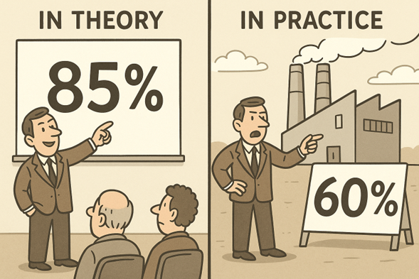

The explanation lay in the structure of the process: a series of interdependent units connected by buffers. While each stage—reaction, separation, solvent recovery—could perform near its peak in isolation, the lack of synchronization between them led to compounding inefficiencies. Temporary mismatches created flow disruptions, starving or overloading adjacent steps.
Mathematically, this behavior resembled a multiplicative system, where overall efficiency is the product—not the average—of individual efficiencies:
OEE_total ≈ OEE₁ × OEE₂ × OEE₃ …
This analytical model explained why the plant had never reached design capacity—and showed that with full-system synchronization and targeted debottlenecking, it could.

🔧 Our Approach
The strategy began by systematically challenging operational conventions—particularly those shaped more by cultural inertia than engineering rigor. Each stage of the process was revisited, not just on technical grounds but also through the lens of human behavior and team dynamics.
Reaction Optimization
The reaction stage was historically constrained below its design rate due to safety concerns, despite evidence of an available performance margin. The acidity level was cautiously increased to its safe upper limit. To offset perceived risk, new sensors were installed for redundant monitoring, and fire suppression was fully automated—ensuring protection even during momentary lapses. This removed a key bottleneck through risk-managed implementation.
Extraction Flexibility
A long-standing convention held that solvent separation times over 12 seconds indicated a limit. Data analysis showed no link between this metric and actual throughput. Operators were instructed to ignore the spec unless real issues appeared, removing an artificial constraint without compromising stability.
Leaching Stabilization
An oversized 4" discharge valve caused unstable flow and contamination. It turned out to be the result of a prior “improvement” to speed up startup events. Reverting to the original 2" design stabilized the process. Operators were guided to slow startup routines, eliminating a chronic limitation and enabling consistent performance at full capacity.
Cooling Redundancy
Seasonal heat reduced cooling performance, affecting yield and quality. Re-activating an idle cooler added capacity but reduced energy efficiency—sparking initial resistance. Still, the trade-off was clear: higher energy cost was far outweighed by throughput and quality gains. Cooling was redefined as a strategic enabler.
A Cyclical, Data-Driven Process
These changes unfolded over nearly three years through observation, data collection, and incremental action. Each round clarified the system and engaged the team further. The site manager who had once laughed at the idea of a 50% gain ultimately saw a near-doubling of output—achieved not through massive spending, but through aligned operations and evidence-based decision-making.
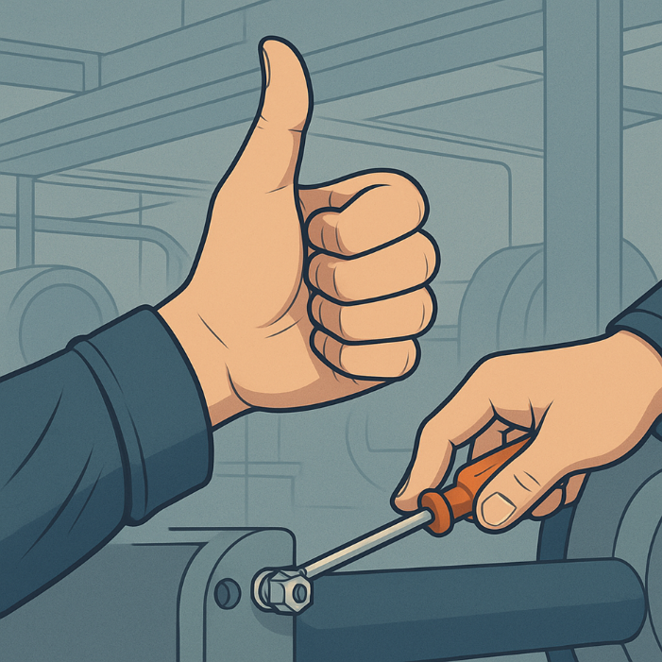

✅ The Results
- Production increased from under 400 to 750 tons/day—up nearly 90%
- Drying energy was halved, thanks to reduced off-spec and rework
- Environmental compliance ceased to be a constraint
- Capital spending was limited to ~$150K vs. a proposed $12M expansion

💡 Takeaway
- Start With the Math, Not the Myth
Assumptions about utilization and efficiency often calcify into “truths.” A data-driven benchmark against design capacity showed the real potential.
- Find the Constraint, Then Repeat
The Theory of Constraints guided each step. Remove one limitation, reassess, and move to the next. Compound gains follow.
- Learn the Process, Then Trust the Design
The more deeply the process and original design were understood, the clearer the fixes became. Facts and fundamentals trump folklore.

Written by Yair Riffkin. With over two decades of experience in operational performance, manufacturing technology, and data-driven process transformation across global industries.
🔗 Connect with me on Linkedin
🌐 Visit Yeda Solutions

